

10 Cambridge Road
Mount Dandenong, 3767
(03) 9751 1624
C.O.L. 515 0438 776 997
A.B.N. 67 506 412 920

Pindone Information (used for Rabbit control)
Program | 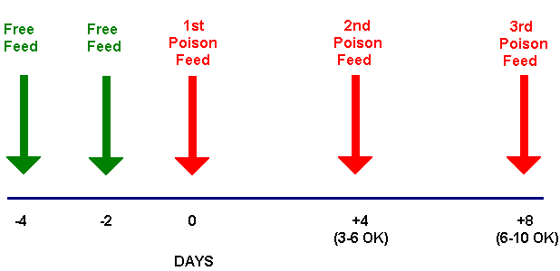
Notification | Notify neighbours seven (7) days prior to commencement of baiting program
Signage | Pindone warning signs on all property entrances
Stock /  Family Pets | Stock and pets to be kept away from baiting sites.  Danger to family pets (e.g. cats, dogs) – only danger if they eat dead Pindone baited rabbits on more than one occasion.
Disposal | Rabbits found dead after each baiting night are buried at a depth of 500 mm
Site Clean Up | Baiting trenches to be filled in or baits removed. Final check to be made for dead rabbits.
Monitor Site | Spotlight site after baiting program to determine if further baiting needs to be undertaken
Antidote | Administer Vitamin K1 to any animal suspected to have Pindone poisoning.

